**How to do test sending PLU in DMC**

* + - 1. Go to DMC, **Menu** > **Configuration** > **Data Export & Import**
      2. Choose Store and Type as Export and click on Exec button

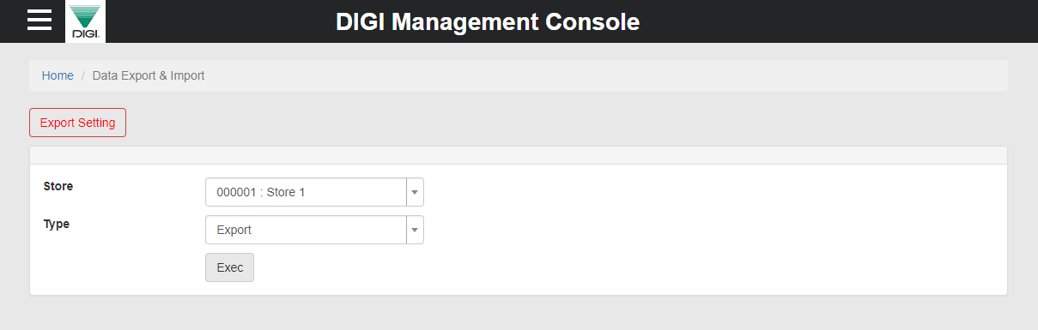

* + - 1. At Store server machine go to **[Report]**

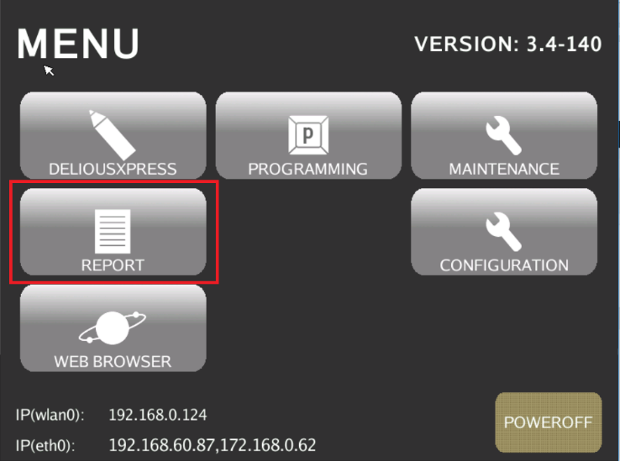

* + - 1. Tap DMC button.

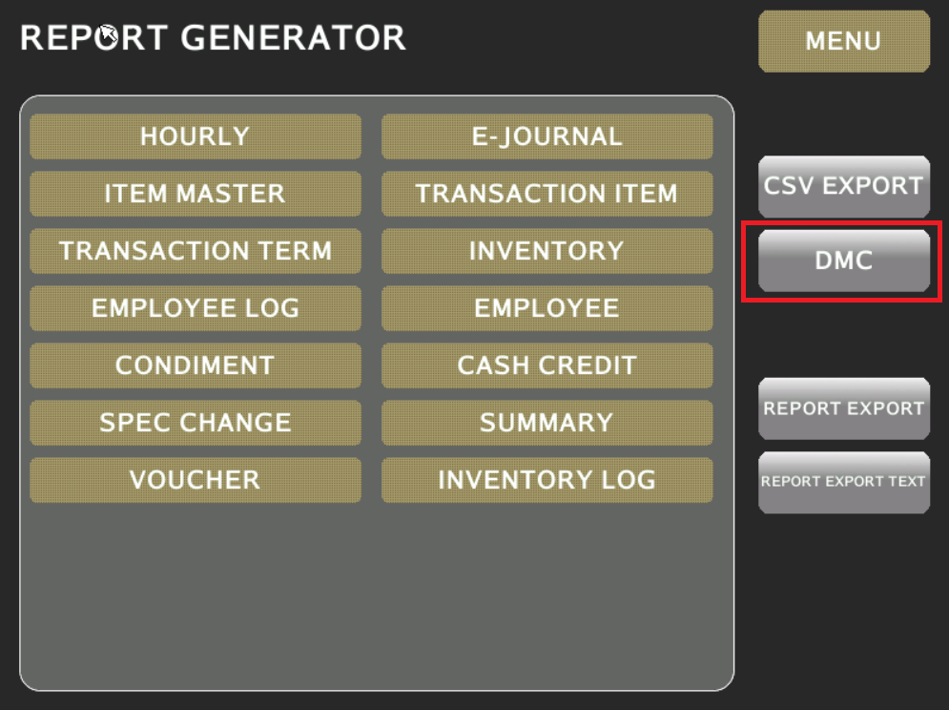

* + - 1. Tap on IMPORT and START

